Loknete ma.Hanmantrao Patil Charitable Trust’s
ADARSH INSTITUTE OF TECHNOLOGY AND RESEARCH CENTRE ,VITA
MSBTE- 0991

FIFTH SEMESTER
(Year: 2023-24)

Micro Project

Micro-Project Proposal
Environmental Studies [22447]
I

Micro-Project Proposal
Environmental Studies [22447]
I

Micro-Project Proposal
Environmental Studies [22447]
I

Micro-Project Proposal
Environmental Studies [22447]
I

Micro-Project Proposal
Environmental Studies [22447]
I

Micro-Project Proposal
Environmental Studies [22447]
I

Micro-Project Proposal
Environmental Studies [22447]
I

Micro-Project Proposal
Environmental Studies [22447]
I

Micro-Project Proposal
Environmental Studies [22447]
I

Micro-Project Proposal
Environmental Studies [22447]
I

Micro-Project Proposal
Environmental Studies [22447]
I

Micro-Project Proposal
Environmental Studies [22447]
I

Micro-Project Proposal
Environmental Studies [22447]
I

Micro-Project Proposal
Environmental Studies [22447]
I

Micro-Project Proposal
Environmental Studies [22447]
I

Micro-Project Proposal
Environmental Studies [22447]
I

Micro-Project Proposal
Environmental Studies [22447]
I

Micro-Project Proposal
Environmental Studies [22447]
I

Micro-Project Proposal
Environmental Studies [22447]
I

Micro-Project Proposal
Environmental Studies [22447]
I

Micro-Project Proposal
Environmental Studies [22447]
I

Micro-Project Proposal
Environmental Studies [22447]
I

Micro-Project Proposal
Environmental Studies [22447]
I

Micro-Project Proposal
Environmental Studies [22447]
I

Micro-Project Proposal
Environmental Studies [22447]
I

Micro-Project Proposal
Environmental Studies [22447]
I

Micro-Project Proposal
Environmental Studies [22447]
I

Environmental Studies (22447)

Title of the Project: “Prepare report on Household Water Filteration Unit”

Branch: Computer Technology (CM5I)

Members of the Group:
- Pratik Rahul Bamane Roll No. -3129
- Sanika Sunil Tirmare Roll No. -3130
- Mrudula Santaji Shinde Roll No. -3131
- Jahir Yasin Kulakrni Roll No.-3132

Loknete ma. Hanmantrao Patil Charitable Trust’s
Adarsh Institute of Technology & Research Centre, Vita

CERTIFICATE
This is to certify that the micro project report entitled

“Prepare report on Household Water Filteration Unit.”
Submitted by
Sr. No. | Name of Student | Roll No.
01 | Pratik Rahul Bamane | 3129
02 | Sanika Sunil Tirmare | 3130
03 | Mrudula Santaji Shinde | 3131
04 | Jahir Yasin Kulkarni | 3132

For Fifth Semester of Diploma in Computer Technology of course Opreating System- 22516 for academic year 2023-24 as per MSBTE, Mumbai curriculum of ‘I’ scheme.

DIPLOMA OF ENGINEERING
(Computer Technology)

SUBMITTED TO
MAHARASHTRA STATE BOARD OF TECHNICAL EDUCATION MUMBAI
ACADEMIC YEAR 2023-24

Project Guide H.O.D. Principal
Mr.S.D.More Prof.A.A.Vankudre Dr. P.S.Patil

MAHARASHTRA STATE BOARD OF TECHNICAL EDUCATION, MUMBAI
MICRO PROJECT
Progress Report / Weekly Report
Title of the Project: “Prepare report on Household Water Filteration Unit”.
Course: EST(22447) Program: Computer Technology (CM5I)
Week No | Date | Duration in Hrs. | Work / Activity Performed | Sign of the Faculty
1
2
3
4
5
6
7
8
9
10
11
12
13
14
15

Teacher Evaluation Sheet for Micro Project

Course Title and Code: 22447

Title of the Project: “Prepare report on Household Water Filteration Unit.”
Group No: 08
COs addressed by the Micro Project:
CO 1:- | Apply the techniques to reduce the Environmental Pollution.
CO 2:- | Developed awareness about environment.

Marks:-
Roll No. | Name Of Student | Marks for Group Work (06) | Marks obtained by the individual based on viva (04) | Total Marks (10)
3129 | Pratik Rahul Bamane
3130 | Sanika Sunil Tirmare
3131 | Mrudula Santaji Shinde
3132 | Jahir Yasin Kulkarni

Name and designation of Faculty Member: Mr.S.D.More
Lecturer (Civil Department)

Signature: _______________________

ACKNOWLEDGEMENT

I express my sincere gratitude to Mr.S.D.More Department of Computer Technology, for his stimulating guidance, continuous encouragement and supervision throughout the course of present work.

I would like to place on record my deep sense of gratitude to Prof.A.A.Vankudre HOD-Department of Computer Technology, for his generous guidance, help and useful suggestions.

I am extremely thankful to Principal Dr.P.S.Patil for this motivation and providing me infrastructural facilities to work in, without which this work would not have been possible.

I would like to express my gratitude to all my colleagues for their support, co-operation and faithful discussions on diverse seminar topics and technical help.

Name of Student | Sign
- Pratik Rahul Bamane
- Sanika Sunil Tirmare
- Mrudula Santaji Shinde
- Jahir Yasin Kulkarni

Index

Sr.No. | Content | Page No.
1.0 | Rationale
2.0 | Course Outcomes Addressed
3.0 | Literature Review
4.0 | Actual Methodology Followed
5.0 | Actual Resources Used
6.0 | Outputs of the Micro-Project
7.0 | Skill Developed / learning out of this Micro Project
8.0 | Applications of this Micro Project
9.0 | Area of Future Improvement

PART A- Micro Project Proposal

Title of Micro-:”Prepare report on Household Water Filteration unit”

- Rationale :

An Introduction To RO Water Purifier. The Reverse osmosis water purification system or RO water purifier is the most popular water purifier in the field of water purification system. RO water purifier is mostly based on the reverse osmosis or RO technique. This technique is the opposite of the simple osmosis process. The difference . between Reverse Osmosis and carbon filtration is the presence of the high-quality Membrane. Activated Carbon Filtration is most effective at removing or reducing impurities and contaminants such as chlorine, sediment, volatile organic compounds, poor taste and odour from water.Reverse Osmosis (RO) is a water treatment process that removes contaminants from water by using pressure to force water molecules through a semipermeable membrane. During this process, the contaminants are filtered out and flushed away, leaving clean, delicious drinking water. RO water is good for drinking because of removal of arsenic , lead and other harmful element by different 2 process carrying by R0 purifier According to WHO report RO water is not safe water. It is unhealthy water. Ro purifier removes all impurities as well as minerals from the water. RO is acronym for Reverse Osmosis, you must recollect your High School Chemistry UV is acronym for Ultra Violet rays, UV rays is used to kill the microbes and germs. TDS is the acronym for Total Dissolved Solids. TDS is adjustable in certain models of Kent Water Purifier. The advisable limit for TDS is 60 to 75.
.

2.0 Aim of the Micro-Project:
A water filter removes impurities by lowering contamination of water using a fine physical barrier, a chemical process, or a biological process. Filters cleanse water to different extents for purposes such as providing agricultural irrigation, accessible drinking water, public and private aquariums, and the safe use of ponds and swimming pools. Water filters are usually recommended if you have a private water supply on your property with a high amount of sediment or is at risk of chemical contamination..

3.0 Intended Course Outcomes:
a) Apply the techniques to reduce the Environmental Pollution.
b) Developed awareness about environment.
4.0 Literature Review:
- www.javapoint.com
- www.tutorialspoint.com
- www.guru99.com

- Proposed Methodology:

- Observe the water filter unit.
- Discus with group about water filters.
- Collect data from internet and books ( environmental studies & water filter units )
- Open the filtration unit
- Observed the parts & read their conclusion 7.Mr. collect some information on internet 8.Mr.collect some picture
- Collected data in books
- Arranged all data & prepare report on it.

6.0Action Plan

Sr. No. | Details of activity | Planned Start date | Planned Finish date | Name of Responsible Team Members
1 | Project Proposal
2 | Data Collection & Analysis
3 | Preparation of Prototype /Model
4 | Preparation of Report
5 | Presentation and submission

PART B- Micro Project Proposal

3.0 Intended Course Outcomes:
- Increase knowledge about water filter units.
- Experience team work
- Increase communication skill
- Know about applications of filters.
4.0 Literature Review:
- www.javapoint.com
- www.tutorialspoint.com
- www.guru99.com

5.0 Actual Methodology Followed

Name: All Members.

Member 1) Name: Pratik Rahul Bamane
Work: Search information regarding project subject.
Member 2) Name:Sanika Sunil Trimare
Work: Collect information and discuss with group members about proposal.
Member 3) Name: Jahir Yasin Kulkarni
Work: Analyze and finalize the information of the project report.
Member 4)Name: Jahir Yasin Kulkarni
Work: Write project report
Member 5) Name: Mrudula Santaji Shinde
Work: Prepare rough sketch and final chart

5.0 Actual Resources Used

Sr. No. | Name of Resource/material | Specifications | Qty | Remarks
1 | Textbook | Environmental Studies | 1
2 | Internet | https://en.m.wikipedia.org/wiki/filters_(camshaft ) | 1
3 | Internet | Chrome | 1

- Skill Developed/ learning out of this Micro-Project:

We know about the household filtration plant. We study the household filtration plant. we produce ability to dissemble the household filtration plant. We see the parts of household filtration unit. We know the working of the household filtration plant. We observe the all part of household filtration plant . now after some time we successfully assemble the Household filtration plant. we know all information about household filtration plant.
- Future Scope:

The future of computer systems is promising, with rapid advancements in various domains. Staying informed about these trends and developments will be essential for anyone pursuing a career or research in computer science and related fields. Additionally, interdisciplinary knowledge in fields like biology, ethics, and sustainability will become increasingly valuable as computer systems continue to evolve.

Output of the Micro-project:-

Household filtration plant
We studied how to water filter unit work and how it’s process done and working principle of it using and related notebook and books and other things related to it like RO is to be resorted to only in cases where the salt content of water to be used for drinking is much higher than advisable.Even here reduction of the salt content to the level of 10 or 20 ppm is counterproductive. If the salt content of the water is very high even for non-potable purposes, rainwater harvesting often works wonders.
In the cases where the water has coliform bacteria, the source for their presence should be delineated and the contamination eliminated. While RO may be advised, elimination of the cause is the safer and preferred route and ultimately the cheaper route also.Those who go in for RO for water with high salt content are well informed to assess the volume likely to be subjected per day and ask the supplier how long will the media work effectively with that volume, what is the cost involved for the replacement of the media and what are the monthly running costs, apart from the capital cost.They also should question any proposal to reduce salt content to less than 500 ppm.

What is requirement of filters in house ?
As per the Bureau of Indian Standards, the desirable quality of drinking water is that which has TDS (Total Dissolved Salts) content of 500 ppm or less (ppm stands for parts of the salt present in a million parts of water). Where water of this quality is not efficiently available, the compromise level is water having up to 2000 ppm
It is to be borne in mind that in some places, iron salts may be present and if the content of iron salts is more than the permissible 0.4ppm, even if the total salt content is less than the desired level, the iron salts will have to be removed before drinking that water. There are also some pockets West Bengal and U.P. where the water contains Arsenic. This is poisonous and so here also the same rule applies. In some pockets again, fluoride salts may be present which affect the bones if that water is drunk. Using this water for non-potable purposes is however not harmful.Another point to be recognized is that water with very low salt content is not very palatable and therefore where the total salt content is less than 500, reducing it to 10 or 20 by RO is not only meaningless from the point of view of wastage of water but also from the cost and loss of palatability aspects. In cases where the salt content is not much higher than 2000 ppm, a simpler route would be to harvest rainwater which will dilute the salts and bring it within potable limits progressively.

1.Reverse Osmosis filters:
Reverse Osmosis (RO) system offers a multi-stage filtration of water by combining active carbon and also particle filtration. Here, the tap water is made to pass through a membrane (a polymer film) that has very small-sized pores and this weed out minerals and micro-organisms in water. The impurities collected are then flushed out through an outlet pipe. A RO water purifier improves the taste of water but, it is difficult to say that the water will be 100 percent safe as at times due to holes (because of a manufacturing defect or due to wear-and-tear) in the filter, some bacteria can get through the filter. RO filters are recommended for places where the problem with the water is its high content of dissolved minerals. The darker side in a RO purifier is that there are chances that the membranes in these filters drain out some of the necessary minerals too. Also, it requires a continuous water supply to function and can be fixed to only one water tap

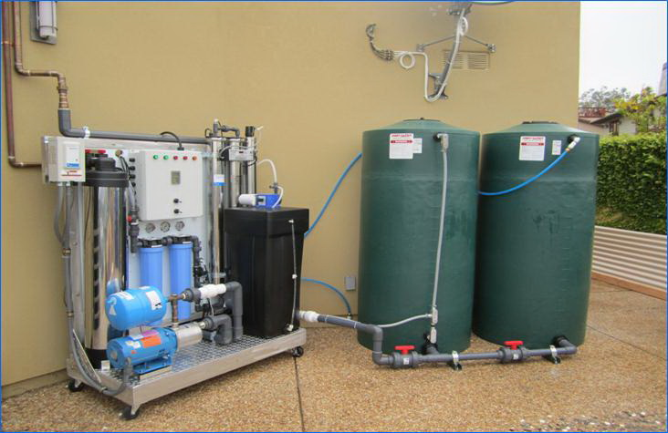

Mechanism of reverse osmosis RO
RO is a process where water having more than the desirable salt content is put in one part of a vessel with two compartments separated by special media and pressure is applied on the water. This results in only the pure water going across the media to the other compartment with the salts remaining in the same compartment. Thus the process results in accumulation of salts in the first compartment. Beyond a certain concentration of salt the process will not proceed further and the water which contains all the salt is rejected. Because of this, if one starts with say 100 parts of water, the process yields only about 70 parts of good water and the other 30 parts which contain all the salts present originally in 100 parts have to be thrown away.
In RO systems of small capacity suitable for domestic purposes, the rejected component may be as high as 45%. The process therefore is a wasteful one with much of the water having to be thrown away Diverting large volumes of this highly salty water into the sewage line could result in acting against the smooth movement of its contents. The reject will not be tolerated by normal garden plants. It will form deposits on the floor and sanitary ware. It is also not advisable to divert it to the septic tank.If the water subjected to RO has less than 1000ppm say, then the salt content in the reject water will not be much and it can be used for gardening or flushing. But the point is that this water need not be subjected to RO at all in the first place.

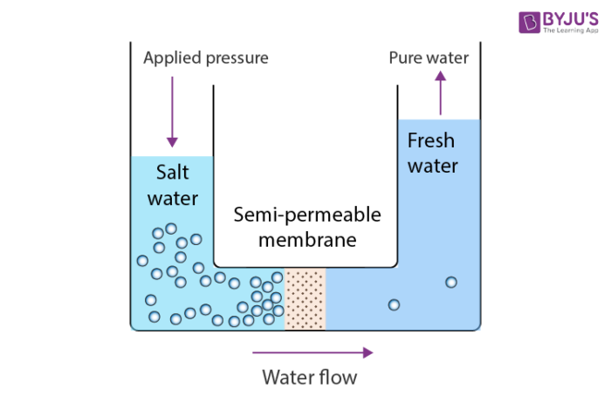

Parts of RO system filtration unit

1.Cold water line valve
It is a valve that fits into the cold water supply line. It has a tube that is attached to the inlet side of the reverse osmosis pre-filter. It is the water source for the reverse osmosis system.

2.Pre-filter(s)
The number of pre-filter used in a reverse osmosis system differs from one another. Indeed, there may be more than one pre-filter used. The most commonly used pre-filter is the sediment filter. This kind of pre-filter is used to remove dirt, sand silt, and another sediment. Other pre-filter, such as carbon filter, can be used too.

3.Reverse osmosis membrane
It is the most important part of the reverse osmosis system. The most commonly used membrane is a spiral wound. There are two kinds, the thin film composite or material (TFC/TFM) and cellulose triacetate (CTA). CTA is chlorine tolerant, while TFC/TFM is not.

4.Post filter(s)
After leaving the storage tank but before going to the faucet, the water goes through post filter. The post filter is generally carbon. It can be in carbon block or granular form. It is used to remove remaining odors and tastes from the water.
5.Automatic shut off valve (SOV)
It is used to conserve water. When the storage tank is full, the SOV stops the water from flowing to the membrane.
6.Check valve
The check valve is located at the outlet end of the reverse osmosis membrane housing. It prevents the backward flow of the water from the storage tank. By doing this, it prevents the membrane from rupturing.
7.Flow restrictor
The flow restrictor is used to maintain the flow rate required to get the highest quality drinking water. It is also used to maintain pressure on the inlet side of the membrane. The flow restrictor is located in the reverse osmosis drain line tubing.

Advantages of RO filters

1.Improves Taste
RO filtration improves taste, odor and appearance of water by removing contaminants that cause taste and odor problems

2.Saves Money
With an RO system, you can cancel your water delivery service and stop purchasing cases of bottled water. Reverse Osmosis filtration provides “better-than-bottled water” quality water for just pennies per gallon.

3.Simple Maintanence

RO systems have very few moving or replaceable parts make RO systems easy to clean and service.

4.Removes Impurities
RO systems remove pollutants from water including nitrates, pesticides, sulfates, fluoride, bacteria, pharmaceuticals, arsenic and much more. An RO systems’ carbon filter will also remove chlorine and chloramines.

Disadvantage of RO purifier:-
- Disadvantages of RO water purifier. Removes essential minerals: While RO water.
- purifier removes dissolved impurities it removes natural mineral such as iron, magnesium, calcium and sodium which are essential to the human body and cause a mineral deficiency in the body Chlorine can damage RO membrane
- Ro water purifier removes essential natural mineral like sodium, iron, calcium, and magnesium that are essential for our body and causes

- Conclusion:-
Water filters are selected by millions of people the world over because they supply a better quality of tasty and great-smelling drinking water due to their natural ability to remove chlorine and other bacterial impurities, thus preventing harmful substances from entering the body.

